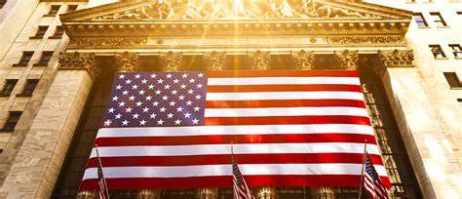

**US BANKING SYSTEM**

**BY - GOTLA SHIVANI YADAV**

**ALLIANCE UNIVERCITY – BANGLORE**

**HISTORY OF US BANKS**

In 1780, merchants traveled from Britain to the United States and set up the Bank of Pennsylvania to help fund the American Revolutionary War. Back then, the Thirteen Colonies didn’t have a formal currency, relying instead on informal trade to manage daily transactions.

On January 4, 1782, the first commercial bank in the U.S., the Bank of North America, opened its doors. By 1791, Alexander Hamilton, the U.S. Treasury Secretary, established the Bank of the United States. This national bank was meant to handle American taxes and pay off foreign debt. However, in 1832, President Andrew Jackson shut it down and redirected its assets to state banks. These state banks began printing money rapidly, causing runaway inflation and eventually leading to the Panic of 1837.

Investment banking took off in the 1860s with Jay Cooke & Company, which was one of the first firms to sell government bonds. The National Bank Act of 1863 created a national currency and a federal banking system, aimed at making public loans more accessible.

However, not all parts of the country were states yet. In Oklahoma Territory, which didn’t become a state until 1907, private banks started to emerge. For instance, in 1902, Muskogee mayor H.B. Spaulding resigned as vice-president of the Territorial Trust and Surety Company to start a private bank through his Spaulding Mercantile Company. Other private banks followed in 1903. A local banker defended these private banks, noting that only a few had failed due to a "dip in deposits from partial crop failure."

In 1913, the Federal Reserve System was created to manage the nation’s monetary policy. The Great Depression led to the Glass-Steagall Act, which separated investment and commercial banking. However, this act was repealed in 1999, setting the stage for the 2008 financial crisis.

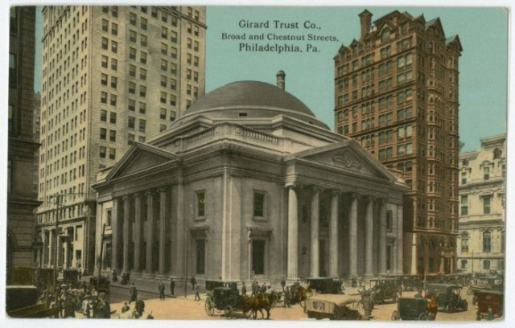

**How U.S. Banks Operate**

U.S. banks are essential to everyday life, providing a range of financial services to people, businesses, and governments.

**Types of Banks**

1. Commercial Banks: These are your everyday banks where you can open a checking account, get a loan, or use a credit card.
2. Investment Banks: They help companies raise money, handle mergers, and manage big investments.
3. Retail Banks: Focus on personal banking services for individuals, offering savings accounts, loans, and more.
4. Credit Unions: These are member-owned banks that often offer better rates and lower fees.
5. Online Banks: Operate mainly online, providing convenient banking services without physical branches.

**Core Operations**

1. Deposits:

You put your money into accounts like checking or savings. Banks may pay you interest and use your deposits to make loans.

1. Loans and Credit:

Banks lend money to people and businesses for things like homes, cars, and business expansions. They earn interest on these loans, which is a major way they make money.

1. Payment Processing:

They handle transactions with checks, cards, wire transfers, and electronic payments. Fees are often charged for certain services.

1. Investments:

Offer investment products like mutual funds and retirement accounts. Provide financial advice and wealth management services.

1. Risk Management:

Evaluate and manage risks in lending and investing. Keep reserves and follow regulations to stay stable.

**Regulation and Oversight**

**1.Federal Reserve System:**

Acts as the central bank, overseeing monetary policy and regulating banks to keep the financial system stable.

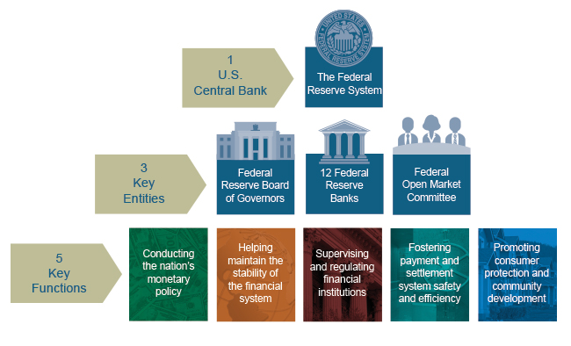

**2.Federal Deposit Insurance Corporation (FDIC):**

Insures your deposits up to a certain amount, protecting your money if a bank fails.

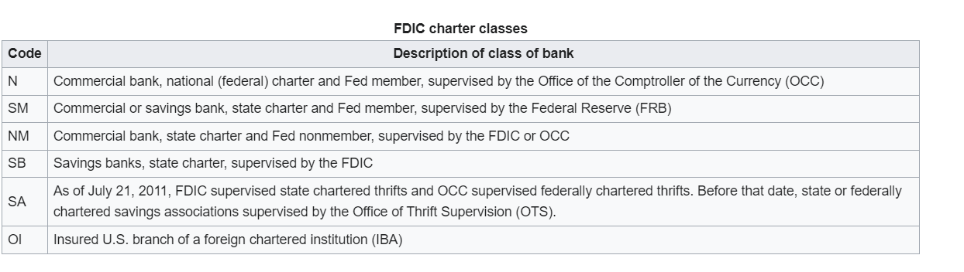

**3.Office of the Comptroller of the Currency (OCC):**

Regulates national banks and federal savings associations.

1. **Consumer Financial Protection Bureau (CFPB):**

Protects consumers by enforcing financial laws and regulations. Technological Integration.

**5. Online and Mobile Banking:**

Banks provide apps and websites so you can manage your accounts, pay bills, and transfer money easily.

1. **Fintech Collaboration:**

Partner with tech companies to offer new services like peer-to-peer payments and robo-advisors.

**Revenue Sources**

* **Interest Income**: Earned from loans and credit cards, it's a big part of how banks make money.
* **Fees and Charges:** Banks charge for account maintenance, overdrafts, and other services.
* **Trading and Investment Income:** Banks also make money from trading stocks and other investments.
* **Risk Management**

Credit Risk: The risk that borrowers won’t repay their loans. Banks manage this by checking credit scores and diversifying their loans.

Market Risk: The risk of losing money due to market changes. Managed by diversifying investments and using hedging strategies.

Operational Risk: The risk of losses from internal issues like system failures or fraud. Managed with strong internal controls.

Liquidity Risk: The risk of not having enough cash to meet obligations. Managed by keeping enough liquid assets.

* **Compliance and Ethics**

Banks follow laws to prevent money laundering and ensure they know their customers. They must maintain ethical practices and good governance to build trust. By balancing these activities and following regulations, U.S. banks aim provide safe, efficient, and innovative services to their customers.

**FLOW OF MONEY**

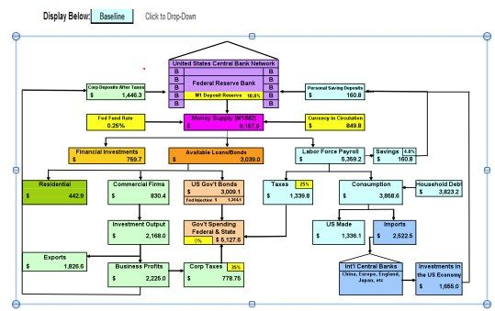

### Currency in the United States

### Historical Background

1. **Colonial Period**:
   * The Thirteen Colonies used various forms of money, including foreign coins, bartering, and commodities like tobacco.
   * The Continental Congress issued Continental currency during the Revolutionary War, which suffered from severe devaluation.
2. **Establishment of the Dollar**:
   * **Coinage Act of 1792**: Established the U.S. dollar as the standard unit of money and created the U.S. Mint. The dollar was originally backed by gold and silver.
   * **Gold Standard**: In 1900, the Gold Standard Act pegged the dollar to gold alone, lasting until 1933 domestically and 1971 internationally.
3. **Federal Reserve Act of 1913**:
   * Created the Federal Reserve System, which issues the Federal Reserve Notes that are the modern paper currency.

### Types of Currency

1. **Coins**:
   * Produced by the U.S. Mint in denominations of 1¢ (penny), 5¢ (nickel), 10¢ (dime), 25¢ (quarter), 50¢ (half-dollar), and $1.
   * Made from metals like copper, nickel, and zinc.

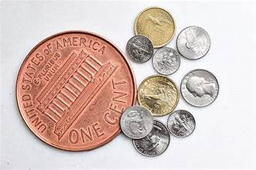

1. **Paper Money**:
   * Issued by the Federal Reserve in denominations of $1, $2, $5, $10, $20, $50, and $100.
   * Features prominent American figures, such as George Washington ($1), Abraham Lincoln ($5), and Benjamin Franklin ($100).

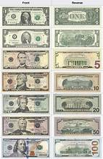

### Security Features

To prevent counterfeiting, U.S. paper money includes:

* **Watermarks**: Images visible when held to the light.
* **Security Threads**: Embedded strips that glow under UV light.
* **Color-Shifting Ink**: Ink that changes color when viewed from different angles.
* **Microprinting**: Extremely small text that's hard to reproduce.
* **3D Security Ribbon**: Found on newer $100 bills, displaying moving images when tilted.

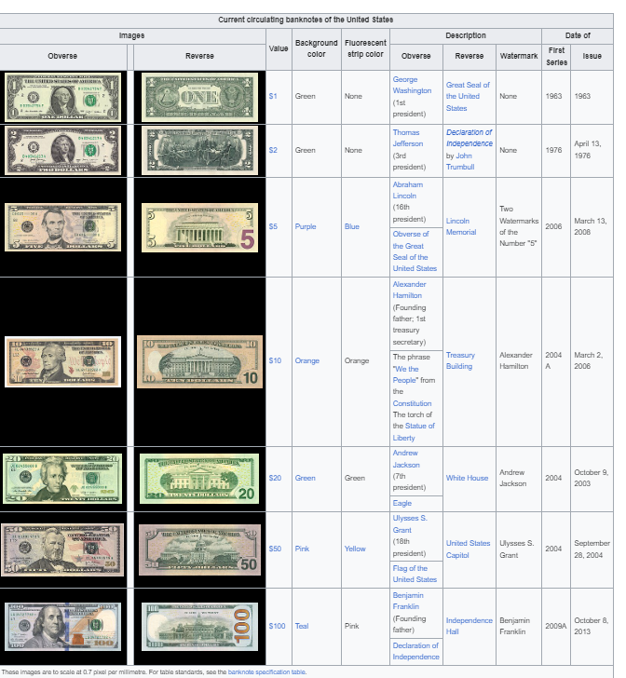

**THANK YOU**